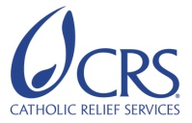

KAP Evaluation Report of Cholera Prevention Programming Activities through CRS Partner Hospitals and Caritas Health Centers

August 2013

Author: Juan Carlos Guzmán, University of Notre Dame

Additional Contributors:

University of Notre Dame
Notre Dame, IN 46556
Mackenzie Dome, University of Notre Dame

Catholic Relief Services
Port-au-Prince, Haiti
Gladys Alcidas, Cholera Program Manager
Ralph Coriolan, M&E Specialist
Kristin Weinhauer, Senior Health Technical Advisor
Sarah Ju, Health Program Quality & Business Development Program Manager
Brian MacDonald, M&E Coordinator
Lam Huynh, MEAL Country Coordinator

Purpose
Catholic Relief Services (CRS) conducted a Knowledge, Attitudes, and Practice (KAP) analysis of project beneficiaries as part of the final evaluation of the Laviktwa sou Kolera project, to assess changes in beneficiaries’ cholera prevention behaviors, their access to essential prevention and treatment materials, and time to seeking treatment. Thus, the purpose of the KAP was to determine the efficacy of the second strategic objective, or the extent to which project beneficiaries have adopted improved hygiene and sanitation practices as a means of gauging the effectiveness of behavior change communication (BCC) and cholera messaging supported by the project. The KAP evaluation assessed percent change in knowledge, behaviors, and practices between the 2012 evaluation results and the 2013 KAP survey to determine how well households adopted cholera prevention behavior.

Methodology
The study population included project beneficiaries receiving services from its affiliated hospitals and health centers. The study was conducted over a period of two weeks in June 2013, using a multi-stage random probabilistic sample by region in the Ouest, Artibonite, Nord, Nord’Est, Nord’Ouest, Sud, and Nippes departments, where the project’s target populations surrounding CRS partner hospitals and health centers are located.

A KAP questionnaire, consisting of knowledge, attitudes, and practices regarding cholera prevention and treatment as well as hygiene behaviors, sanitation practices, and demographics developed by the evaluation team, was used to collect information from the sample project beneficiaries. The questionnaire utilized was a modified version of the one used by the Centers for Disease Control (CDC) survey work conducted in Port-au-Prince in March 2011.
Within the area covered by each partner hospital, we drew a sample proportional to the population size (PPS) to determine the number of surveyed households for each locality within a commune. The sample design was formed in two stages: first, the catchment areas were divided in enumeration areas (EA) according to the 2003 Population Census. Two areas for each commune were selected, one in a village and another in a rural area. If there were no rural or village areas, the two EA were selected from the same type of area. Enumerators were instructed to go the selected area, count the number of households, and divided the number of households by the number of surveys they needed to complete (the sampling interval). After that, they selected by drawing the first household to interview, and the others were selected by adding the interval calculated in the previous step. Due to the difficulty in accessibility of some households in the catchment area, random sampling methodology for the selection of households was at times compromised.

The survey questionnaire was administered by trained interviewers using iPod Touch™, with oversight from trained and experienced supervisors. Female heads of household, as they are often the primary caretakers and responsible for household hygiene, were sought as preferred respondents; if they were unavailable, a person over the age of 18 years was interviewed. All participants gave their verbal consent prior to administration of the survey and were informed of the right to decline participation at any time. In total, 776 valid surveys were collected to represent the population affected by the project.

A year before the final evaluation, health facilities regulated by Caritas enrolled program activities. Results obtained from the Caritas versus CRS health facilities were compared and analyzed, and there were no statistically significant differences.

The comparison between the KAP surveys collected in 2012 and 2013 was done using communes sampled in both surveys. There are small differences between the two questionnaires. Whenever there was a change in the question or the responses, the 2012 KAP answers were adapted to match the 2013 questionnaire.

In total, 14 communes are in the analyses presented in this document: Anse a Foleur, Aquin, Capotille, Cotes de Fer, Croix des Bouquets, Fond des Negres, Fort Liberté, Gros Morne, Limbé, Port de Paix, Saint Louis du Nord, Terrier Rouge, and Trou du Nord.

To the fullest extent possible, we are reporting numbers that are statistically significant different from zero. A statistical significant difference between 2012 and 2013 at 90% confidence is marked with a “*”. We use robust standard errors for all statistical tests.

Results
This section introduces the results of each of the different sections of the questionnaire. We examine knowledge of cholera, water sources and treatment, hygiene and sanitation, and rehydration treatment (or oral hydration solution or ORS).

Cholera Knowledge and Attitudes:
Knowledge of the most important symptoms of cholera (watery diarrhea, diarrhea, and fever) remained unchanged. Cholera is presented with diarrhea and vomiting, and when these symptoms occur, the lack of immediate recognition and treatment of the resulting dehydration may be life-threatening. Over 90 percent of the respondents identified watery diarrhea or diarrhea as symptoms of cholera, and over 80 percent of respondents identified vomiting as a symptom of cholera. Other symptoms like fever (5 to 1%, respectively) and no appetite (3 to 1%, respectively) were identified at a lower frequency by the respondents in 2013 compared to 2012. However, the percentage of the respondents that identified stomach ache as a symptom nearly doubled from 12 to 20% in 2012 to 2013. Diarrhea, vomiting and stomach ache are usually symptoms of gastroenteritis, which could be results of a viral or bacterial infection.

If examining only 2013 data and comparing the areas served by hospitals versus community health workers (CHWs), we find differences in the knowledge of cholera symptoms. The percentage of people identifying diarrhea and vomiting as symptoms of cholera is lower in thte population served by CHWs (34 %) than the population served in the hospitals' catchment area (51%, p-value 0.073). In the case of vomiting, the percentages were 78% and 91% respectively (p-value: 0.036).

There is no improvement in the respondents’ knowledge of how a person might contract cholera. The response “Don’t know” remained at almost 50%. Meanwhile, “Drinking contaminated or untreated water” was identified by less than a third of the population. The belief that cholera is contracted by “Swimming” decreased from 16 to 4% between 2012 and 2013. In contrast, the belief that cholera is contracted by “Flies, mosquitos or insects” doubled from 5 to 10% between 2012 and 2013. The population’s knowledge must be improved in order to increase prevention behaviors.

In 2013, it was almost universally understood that if someone has cholera, they should go to a health facility or cholera treatment center (CTC). The percentage of the population that would seek treatment in a health center increased from 77to 91% between 2012 and 2013. A very small percentage of the population reported to seek help at oral rehydration points (ORP) and cholera treatment centers (CTC). In addition, there was a statistically significant drop (6 to 0% respectively) from 2012 to 2013 in the respondents who identified “Don’t know” for where to seek treatment for cholera.

Improving knowledge of how to protect against cholera is critical in creating targeted informational programming to promote behavioral change in hygiene and sanitation practices. Over 80% of respondents correctly reported “Washing hands” as important in protecting against cholera, while nearly 75% claimed to know to treat their water. 42% knew to cook their food well prior to consumption, while only about 32% knew to wash fruits and vegetables, and 41% = knew to use latrines or toilets.

These percentages have been stable over the last two years. The only detectable statistical difference found was an increase in the knowledge to clean the home with bleach from 20 to 32% in 2012 to 2013, and a decrease in reporting “Other” methods from 10 to 5% in 2012 to 2013.

Between 2012 and 2013, there has been a shift in the knowledge of what to do if someone in the household had persistent diarrhea. From 2012 to 2013, 76% to one third of the respondents stated that they would go to a health facility, and 58% preferred to treat at home. This change could be the result of the population feeling more competent in treating persistent diarrhea at home or giving less importance to the seriousness of the symptom. However, almost all would consider seeking care at a health center after probing for it.

In terms of barriers to accessing health facilities, the percentage of the respondents that identified transportation, money, no space in the health facility, and distance has decreased between 2012 and 2013. Transportation was noted by 41% of respondents as the most important barrier in 2012, which decreased to 23% in 2013. Money was cited as lesser issue with 30% in 2012 and 12% in 2013 reporting it as a problem. However, “Other” barriers increased from 16 to 36% in 2012 to 2013.

The knowledge that the best way to treat cholera at home is by providing the oral rehydration solution (ORS) increased significantly. Other alternatives to cholera treatment that are not preferable were reported less. Tea or traditional medicine decreased to 1% in 2013, and “Do nothing” also decreased to 0%.

Water Sources and Treatment:
The main source of drinking water comes from boreholes with a hand pump (30%), followed by treated water from a kiosk (26%) and river water and other open sources (22 %). People who use an open source for drinking water are at a higher risk of contracting cholera than those who do not use an open source. However, depending on how people store water, the risk could also increase when other sources are used.

The treatment of water is a key element in the prevention of cholera. Boiling water, treating with Clorox, high test hypochlorite (HTH), and Aquatabs are the most common ways to treat the water. Aquatabs are the preferred method reported. Its use increased from 57 to 71% from 2012 to 2013. Also, Clorox use increased from 35 to 56%.

Although the percentage of respondents that report treating their water for drinking and cooking remained unchanged, direct water consumption was statistically significantly reduced between 2012 and 2013. Direct water consumptions for drinking and cooking both decreased from 89 to 26% and 90 to 42%, respectively, from 2012 to 2013.

After the interviewers observed where people stored their water, they asked if the water was treated and how long ago the treatment done. 78% of the respondents reported having treated the water, but 51% treated the water more than 24 hours ago, which increases the likelihood of recontamination.

Hygiene Knowledge, Attitudes, and Practices:
Hygiene knowledge, attitudes, and practices were measured both directly and indirectly. Interviewers asked the respondents to show how and where they wash their hands, and observed how they store their water for drinking and hand washing. In addition, interviewers read a series of statements, to which respondents were asked to agree or disagree, in order to measure the participants’ beliefs and attitudes toward the hygiene practices recommended by the Ministry of Public Health and Population (MSPP).

- Hand Washing and Water Storage
Approximately 30% of respondents knew to wash hands before cooking, and 88% knew to do so before eating, a statistically significant increase from 76% in 2012. Over 87% knew to wash hands after using the latrine or toilet, also a statistically significant increase from 74% in 2012. Generally, hand washing practices after caring for a sick person, cleaning a baby or child, returning home from the street, and using something touched by others were similar to 2012 data, but still lower than desired, reflecting a lack of knowledge of how cholera is contracted. That stated, washing hands after using something touched by others increased from 31 to 43% from 2012 to 2013.

Upon examining storage of water for hand washing, it was found that 68% of the respondents stored their water in a basin or washbowl, a statistical significant increase from 35% in 2012.

Hand washing is critical part of cholera prevention. The technique to hand washing includes using soap; rinsing hands with water; and preferably drying hands by airing them or using a paper towel. The percentage of those using water and soap increased from 80 to 89% from 2012 to 2013. The percentage using ashes and other items decreased from 5 to 3%.

In terms of techniques for washing hands, there has been an overall increase in good practices. The use of sinks to wet hands more than doubled from 24 to 57% from 2013 to 2013. Scrubbing the palms of the hands also increased from 49 to 88%. However, there was no significant change in the percentage of the respondents that scrubbed their nails or fingers (42 to 58% in 2012 to 2013, respectively).

- Hygiene Beliefs
In terms of hygiene belief about water and food consumption, most people acknowledge the need to treat drinking water at home. However, there was a decrease in the percentage of people who believed that their neighbors and friends were doing the same (there was a higher percentage of those answering with “Don’t know”).

Other beliefs that are consistent with improved knowledge of cholera prevention improved between 2012 and 2013. The percentage of those who believe that treated water was only for drinking decreased substantially from 83 to 23%. The percentage agreeing with the statement that cooked hot should be eaten when hot increased, as well as the percentage that believes that dried foods should be kept separated from cooked food.

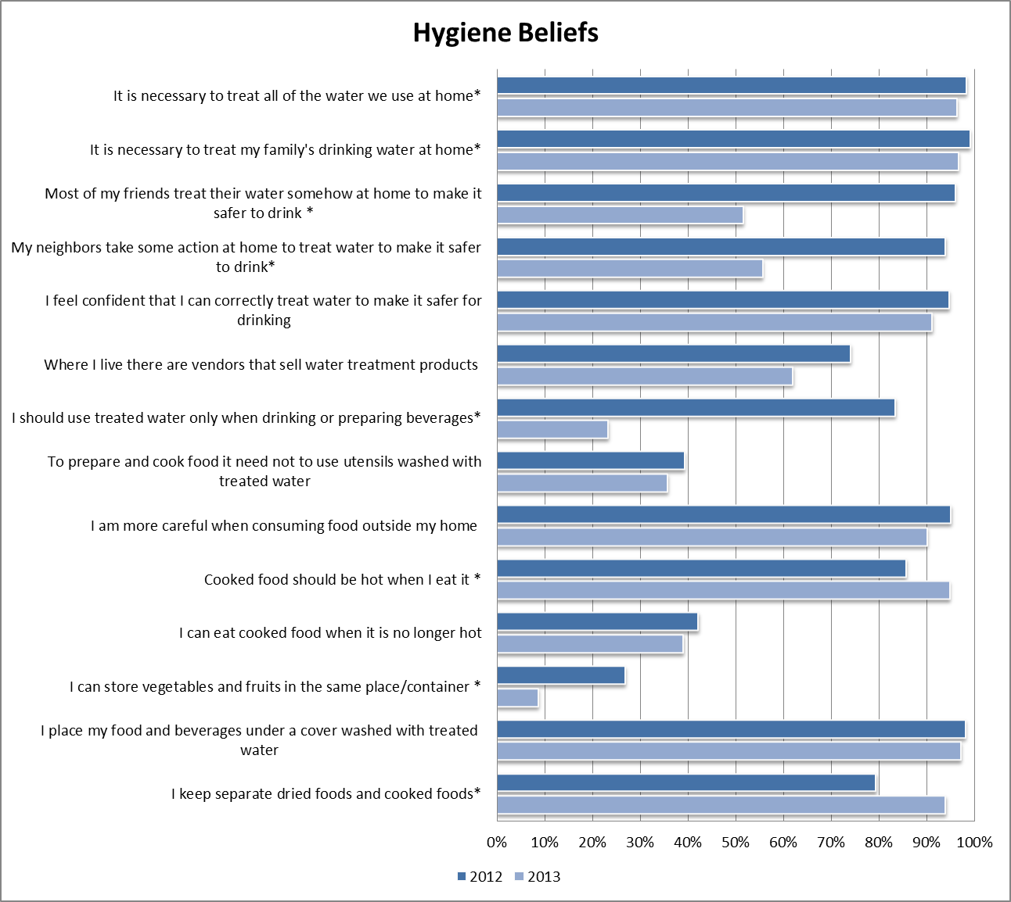

Sanitation:
The biggest concern in cholera transmission is shedding, or the release of the V. cholerae bacterium into the aquatic environment through defecation. Defecation practices did not show a measurable change. However, 17% of respondents reported open defecation practices. These results indicate that open defecation practices must still be reduced through the encouraged use of plastic bags or properly dug pit latrines in the absence of either public or private latrines or toilets.

Rehydration Treatment:
A statistically significant change in knowledge of ORS was detected from 2012 to 2013 at 80 to 99.9 reporting knowledge of ORS. Notably, in 2012, fewer than 55% of respondents knew that a sugar-salt solution is an acceptable alternative for ORS, with respondents showing slightly less knowledge in 2012 than in 2011.

The format of the question regarding knowledge on the preparation of ORS was changed in 2013 from 2012. In 2012, respondents were asked if they knew how to prepare ORS. In 2013, they were asked to explain how to prepare ORS. The questions were classified in three categories: competent, partially competent, and inadequate. In the case of ORS, an answer was classified competent if they mention all the ingredients in the right proportion (ORS packet and water). We accepted answers as competent with a range of water values between "3 small bottles of water" to "2 liters of water." If the water value was out of this range (i.e., 2 small bottles of water, or a gallon of water), it was a partially competent answer. We also accepted soda water and soda as acceptable liquid substitutes. Because of the differences in the questions, we decided not to perform statistical tests.

There is a remarkable difference in the responses between 2012 and 2013. In 2012, almost 77% said that they know how to prepare ORS. However, in 2013, only a third of the population was competent or partially competent on the preparation of ORS.

Knowledge on the alternatives to ORS decreased between2012 and 2013. The best ways to replace fluids and electrolytes are through a sugar-salt solution or pedialyte for children. In the case of the sugar-salt solution, there was statistically significant decrease by 10% of those identifying it as an alternative. There was no detectable difference between 2012 and 2013 for knowledge of pedialyte. The percentage of respondents identifying water statistically significantly increased from 12 to 30% from 2012 to 2013. Also, there was no detectable difference in the percentages of respondents who answered “Don’t know” as an alternative between 2012 and 2013, staying around 20%.

Similarly to the question on how to prepare ORS, there was a change in the question on knowledge on how to prepare sugar-salt solution as home. In 2012, respondents were asked if they knew how to prepare a sugar-salt solution. In 2013, respondents were asked to explain how to prepare a sugar-salt solution. The questions were classified in three categories: competent, partially competent, and inadequate. In the case of sugar-salt solution, an answer was classified competent if the proportions of salt to sugar were no greater than 1:3. If the proportion of salt to sugar was greater than 1 to 3 it was partially competent. However, these proportions of salt to sugar are very important and too much of either could be detrimental to the individual. Because of the differences in the questions, we decided not to perform statistical tests.

Contrary to ORS, the percentage of respondents saying they know how to prepare a sugar-salt solution in 2012 and the percentage that were competent in preparing it were similar (65 and 55% respectively).

Analysis and Discussion
In this section, plausible explanations for all major findings and discrepancies are discussed, with attention given to general trends rather than to statistical significance alone.

The population’s knowledge of the most important symptoms of cholera (watery diarrhea, diarrhea, and fever) and of how a person might contract cholera remained generally unchanged with no significant improvement over time. This lack of improvement in knowledge regarding cholera causes and characteristics may be a result of several factors, including the respondents’ decreased responsiveness in order to attract greater benefits. People may be motivated to respond in ways that might lead to greater local attention, to leverage increased provisions and services. Also, this finding may indicate people growing tired of or health workers growing careless about cholera messaging, particularly during the latest interval of decreased incidence during the dry season.

On the contrary, there has been a significant increase in knowledge of what to do if someone in the household has persistent diarrhea. There was an interesting preference for home treatment with a decline in respondents identifying that they preferred to treat cholera at a health facility. This shift may be due to the population feeling more competent in treating persistent diarrhea at home, or conversely, the population giving less importance to the seriousness of the symptom. It could also allude to increased barriers in reaching health facilities. Although transportation and money are no longer the leading obstacles to health facility access, the largest obstacle to reaching a health facility was cited as ‘Other.’ This unknown factor is concerning as it may have contributed to the decrease in preferring treatment at a health center.

The percentage of those who report treating their water for drinking and cooking did not significantly change, although direct water consumption reduced. The observed increase in water storage in basins may be due to emphasis on reducing contamination, and it may explain the decrease in the use of buckets – a riskier means of storing water due to greater potential for contamination. The increased use of basins or washbowls is likely safe since they are most likely covered. As well, leaving treated water sitting for more than 24 hours slightly increased, and there was a general decline in the amount of respondents that treated water at all. Overall, Aquatabs remain the most popular method of water treatment, followed by Clorox.

Though all respondents report knowledge of oral rehydration solution (ORS), there is less consensus around general hygiene beliefs. Where respondents self-report high knowledge of the necessity to treat all water used to drink and cook at home, respondents are less convinced of their neighbor’s knowledge. This may demonstrate the skepticism that accompanies these programs, and the long-term education needed to reach the entire community. More concerning, this highlights the possibility that respondents are not fully truthful about their self-reported practices if individuals are self-reporting high hygiene behavior and others are consistently observing that the community in general has low hygiene knowledge and practices. Additionally, this is possibly demonstrating how hard it is to change people’s preferences.

In 2012, the majority of people answered that they did know how to prepare ORS. However, in 2013, most people provided an inadequate description on how to prepare it. There was more consistency between the two methodologies in the sugar-salt solution. However, the main takeaway is the consistent lack of knowledge on these methods with an increase in those treating diarrhea at home and no change in those practicing open defecation. Although this may not be problematic now given the low incidence of cholera, these behaviors may result in dangerous cholera surges.

Recommendations
The results of the final KAP survey identify the key areas in which projects beneficiaries have successfully adopted cholera prevention and treatment behavior, as well as areas in which the population may require continued cholera programming to improve knowledge, attitudes, and practices. The following are some reflections.

- Increase knowledge of how cholera is contracted – Approximately 50% of the population still do not know how cholera is contracted which prevents people from taking proper preventative measures.
- Investigate further the barriers to accessing health facilities – Though transportation and money are no longer the leading obstacles to health facility access, other unknown barriers have developed. This is concerning as a majority of the respondents cite “Other” as the largest obstacle to accessing health facilities. This necessitates the further investigation of what these barriers may be.
- Stress water treatment to population – Water sources left untreated cannot be used drinking or cooking, unless filtered or bottled, and water after 24 hours post-treatment risks becoming re-contaminated. This will include methods of water sourcing, and water storage.
- Future surveillance should be aware of the weakest factors at the base of all the behavior and practice issues observed – knowledge of cholera contraction and hygiene practices. With the improvement of knowledge about cholera, more people will adopt proper hygiene and sanitation practices.
- Increase knowledge on ORS, sugar-salt solution, and alternative methods for rehydration – Those with financial and transportation barriers can then have the capacity to immediately and effectively treat sick individuals at home.
- Reduce open defecation in fields and water sources – This can be accomplished through the improvement of personal hygiene and sanitation knowledge, attitude and practices, and thus reduce potential environmental contamination and transmission.
- Maintain good hand washing practices – This is the most reliable reflection of knowledge and understanding of cholera transmission and prevention, and was significantly improved during the program. However, further surveillance and improvement would be beneficial over time.

The program effectiveness and impact can be attributed to the continued surveillance and ongoing monitoring and evaluation systems. Continuous monitoring and evaluation have shown to be a critical part of the programmatic agenda of institutions such as CRS, and they should be included in the future design and implementation of all programs.

